CHANGE CONTROL

VERSION | DATE | CHANGES | AUTHOR
1.0 | 01/29/2020 | New Document | Exelyn Caborda

APPROVAL OF THE DOCUMENT

ROLE | NAME | DATE
RPA LEAD DEVELOPER | Englebert Diongson | 02/03/2020
SERVICE OPERATION MANAGER

- INTRODUCTION
  - PURPOSE OF THE DOCUMENT
The purpose of this document is to outline the deployment information related to the implementation of Robotics Process Automation (RPA) using UiPath for the process of Voice Activation. This details the preconditions in running the robot/s, maintenance activities for the robot/s, schedule of operations, and issue categorization for business reference.

The key features of the automated process demonstrate the following:
- Automation of Voice Activation - Uploading job orders from ICCBS to orchestrator queue
- Automation of Voice Activation - Queuing tasks from obtaining job orders in the orchestrator
  - SCOPE
This document covers the definition of terms used in Voice Activation preconditions on running the robot, manually running the robots, monitoring the robots, and troubleshooting. Also covered in this document are the contact information of the key persons in the deployment and operation of the processes and contingency plans.
- DEFINITIONS
  - DEFINITION OF TERMS
TERMINOLOGY | DEFINITION
UiPath | The automation tool used in developing robot/s.
UiPath Robot | A software robot that is developed to execute the tasks on an interface level and mimic human actions within the systems.
UiPath Orchestrator | Allows a company to schedule, manage, and monitor all robots in one secure place.
Package | The developed robot scripting that is deployed in the orchestrator.
Asset | Represents shared variables or credentials that can be used in different automation projects.

  - ACRONYMS
ACRONYM | DEFINITION
RPA | Robotics Process Automation
URL | Uniform Resource Locator
VA | Voice Activation
VIMS | Virtualized IP. Multimedia Services

- VERSION CONTROL
  - LIST OF PROCESS DEPLOYMENTS

DATE | PACKAGE IDENTIFICATION | DESCRIPTION OF CHANGES
06/19/19 | 1.0.7109.33542 | - Enhancement on closing of multiple browsers and adding retry reading, writing on googlesheet  - Work order with EXTC/INST and Cancel Status Y to be log in successful tab  - Get Cabinet number
07/15/19 | 1.0.7135.24433 | Enhancement on closing of multiple browsers
07/31/19 | 1.0.7151.38856 | VEH Merging + Update LuzVismin File as of 7/30
01/27/2020 | 1.0.7331.30686 | Enhancement on Generation of script w/o Excel

  - LATEST VERSION INFORMATION
VERSION: 1.0.7331.30686
PACKAGE NAME | Performer_-_Voice_Activation
PACKAGE DATE CREATED | January 27, 2020
RELEASE NAME | Performer_-_Voice_Activation.1.0.7331.30686
RELEASE DATE CREATED | February 4, 2020
RELEASED BY | Neutron Team
RELEASED FOR | Deployment
PURPOSE OF RELEASE | Deployment of Generating of Script without Excel
RELEASE FILE LOCATION

- ROBOT/S
  - PRECONDITIONS ON RUNNING THE ROBOT/S
Before the bot can automatically run, we have to ensure the following:
- Package is uploaded in Orchestrator.
- Robot is connected and available.
- Schedule set in Orchestrator is correct.
- Google account is set-up.
- Assets (Credentials, URLs) are updated in Orchestrator.
- VIMS is already logged in.
- VIMS pop-up in Internet Explorer should be set to Allowed.
    - PACKAGE
Ensuring that there is a package uploaded
- Connect to the local host of the orchestrator server: vmbbrapd01 by opening in web browser: https://erpaorchestrator.globe.com.ph/

Tenant name: bb-prod
Username or email: admin
Password: helloBB@12345

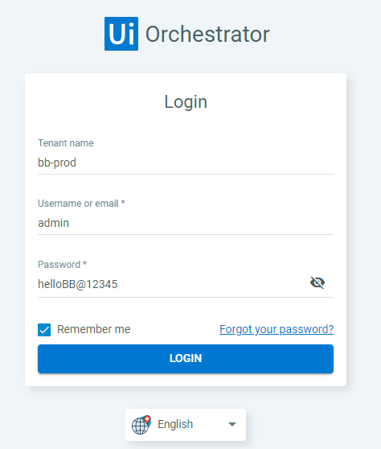
- In the left sidebar, go to Processes, and make sure that there is a package uploaded and it is linked to the environment (Performer - Voice Activation).
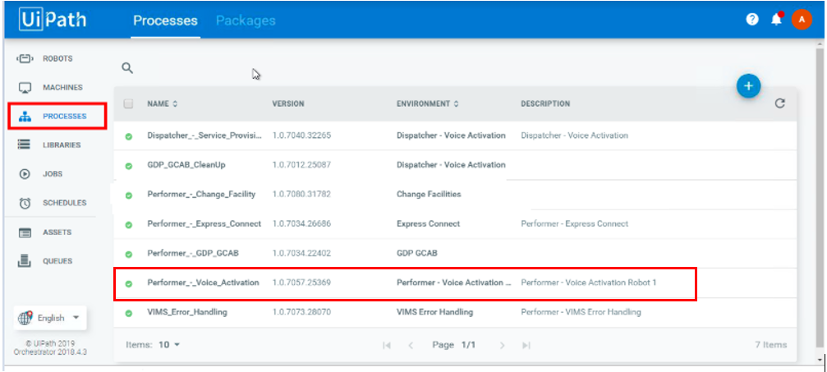
    - ROBOT
Ensuring that the robot is available/busy
- In the left sidebar, Go to Robots, and make sure that the status of the Robot is Available. Once the job is triggered via the schedule (see Section 2.3 for the Scheduling), the status of the robot will be Busy.
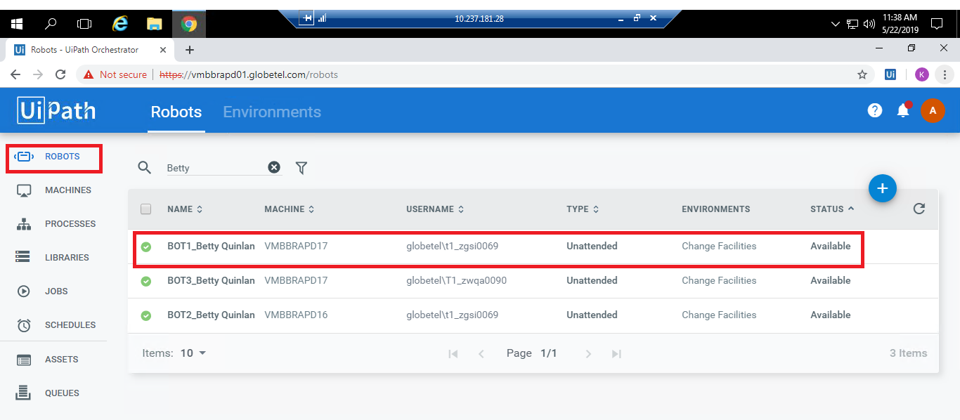
- The possible statuses of the robots are listed below:
- Available - the Robot is not running a process and is free to be used; or waiting for the scheduled activity.
- Busy - the Robot is running a process;
- Unresponsive - the Robot and Orchestrator have not communicated in the last two minutes - the default scenario. This value can be configured in the web.config file.
- Disconnected - the UiPath Robot service is not running.
    - ASSETS
- In the left sidebar, go to Assets, and make sure that the credentials and URLs are correct. The credentials and links value can be manually updated in the orchestrator
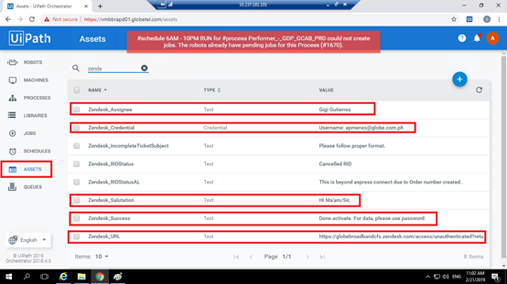
ASSET:
- ICCBS_URL_Prod – URL for ICCBS production
- VA_GoogleSheet_Password – API Google sheet password
- VA_KeyPath – API Keypath for Google sheet
- VA_GoogleSheet_ServiceAccountEmail – API Google sheet email
- VA_GoogleSheet_Error_SpreadSheetID – google sheet id used for retrieving all the consolidated details in error/ fallout isolation cases.
- VA_Success_Job_Details – Tab of the google sheet where the bot will write the successful transactions of the bot
- VA_Fallout_Job_Details – Tab of the google sheet where the bot will write the error reports
- VA_AreaCode_Proj8 – an asset for Area to be access by bot

Config File – Settings
- OrchestratorQueueName – an orchestrator queue name and it must match the name of the server.
- logF_BusinessProcessName – a logging field which allows you to group the log data of two or more sub processes under the same business process name
- ICCBS_Credential_Voice_Activation – a credential for the user to login to ICCBS.
- VA_DeletionScript – a script format for deleting of facility
- VA_G2GActivationScript_SIP – a script format for SIP installation of new facility.
- VA_G2GActivationScript_NONSIP – a script format for NonSIP installation of new facility.

    - SCHEDULE
Ensuring that the preferred schedule running time of the bot is configured in the orchestrator
- In the left sidebar, go to Schedules, and make sure that the details of the schedule is correct.
- The image below is an example for checking of schedule.
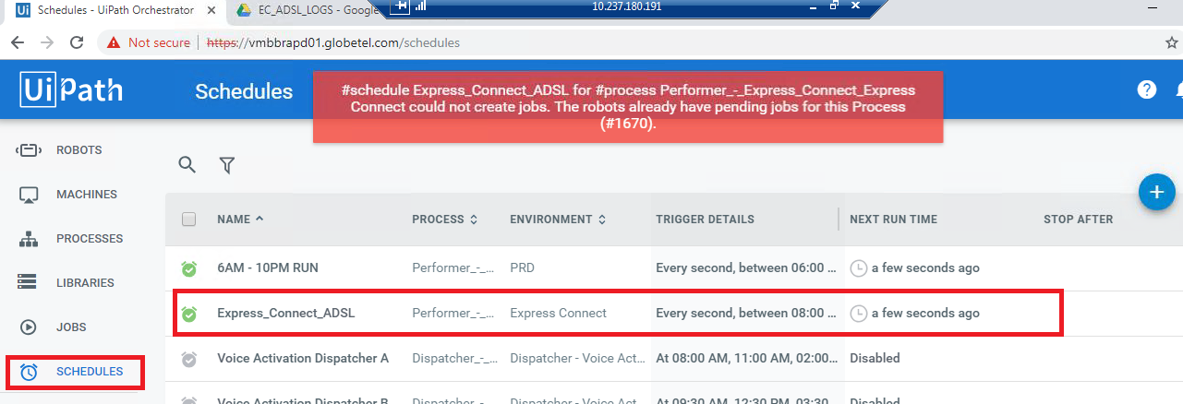

    - OTHER PRECONDITIONS
Ensuring that the Google account is logged-in

- In Google Chrome, ensure that a Google account is logged-in.
- In the Change Facilities – Consolidated Success and Error Report, ensure that the Google user is authorized to run the script in the Google sheet.
  - MANUALLY RUNNING THE ROBOT/S
In any case, the robot have to run out of the predefined schedule set in orchestrator, steps in manually running the robot are stated below:
- In the desktop taskbar, click the UiPath icon, and click the Start button, in order to manually run the bot.
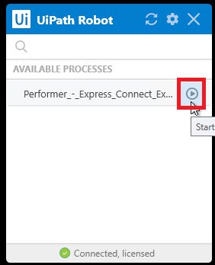
  - MONITORING THE ROBOT/S
    - HEARTBEAT OF THE ROBOT/S
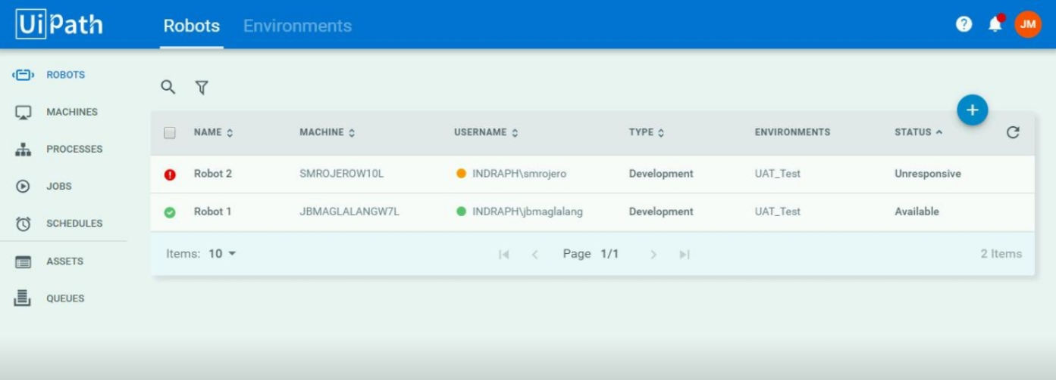
The possible statuses of the robots are listed below:
- Available - the Robot is not running a process and is free to be used; or waiting for the scheduled activity.
- Busy - the Robot is running a process;
Note: When the status of the robot is Busy, do not access/interrupt the desktop/ remote desktop (for virtual machines) as the robot will stop the current session.
To check on the current activity/screen of the robot/s, use a different server (10.237.180.191) in accessing the remote desktop.
- Unresponsive - the Robot and Orchestrator have not communicated in the last two minutes - the default scenario. This value can be configured in the web.config file.
- Disconnected - the UiPath Robot service is not running.
  - ALERTS
Alerts will impact the process and business drivers. There may be a requirement for them to execute actions based on the alerts produced. In this section if they number all the alerts and their communication method and how to act in face of all the alerts produced by the robot, it must be in the ODH.

ALERT MESSAGES | SYSTEM  OR  BUSINESS | COMMUNICATION  METHOD AND  RECIPIENTS | ACTIONS  OPERATION OR BUSINESS TO TAKE | EXPECTED RESPONSE TIME
System Error | System, which occurs in Init state then it will go End Process state. |  | All working application will be closed.
Business Rule Exception | Business, which an error rooted in the fact that certain data which the automation project depends on is |  | Bot consolidate the details in Google Sheet with Error Reason. Then, proceed to another transaction.

  - TROUBLESHOOTING
    - ROBOT/S STOP RUNNING
When the robot/s stopped running, there are two reasons as to why it happened:
● Robot/s stopped running the job; or
● Robot/s became Unresponsive or Disconnected
    - ROBOT/S STOP RUNNING THE JOB
- Check the status of the robot/s: Go to Robots on the left sidebar.
- In this scenario, the Robot/s should still be Available. The robot/s just stopped running the job as it experienced an unhandled exception.
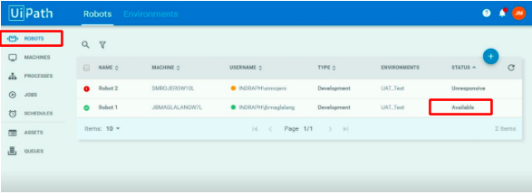
Resolution: For unattended robot/s, we just have to wait for the Orchestrator to run the next job. The predefined schedule will trigger the next job.
- It is recommended to monitor the next run of the bot by accessing the remote desktop through a different server (.191), to check as to why the bot stopped running the job.
- Double check if all the Preconditions on Running the Robot/s (see Section 4.1) are correctly defined.
- Double check if the robot/s have processed the last entry in the Monitoring sheet completely, or will be needing manual intervention.
    - ROBOT/S BECOME/S UNRESPONSIVE OR DISCONNECTED
- Check the status of the robot/s: Go to Robots on the left sidebar.
In this scenario, the Robot/s should be Unresponsive or Disconnected. This happens when the connectivity between the robot and the Orchestrator was lost, or the UiPath Robot service itself has stopped.
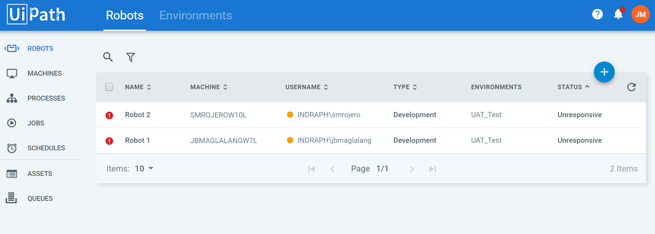
Resolution:
- In the right side of the Windows taskbar, check if the UiPath Robot is still running in the virtual machine.

- Check the status of the UiPath Agent in the taskbar. Should be Error connecting to Robot Service.
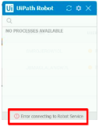
- Go to Windows Services by pressing “Windows” + R” and type services.msc.
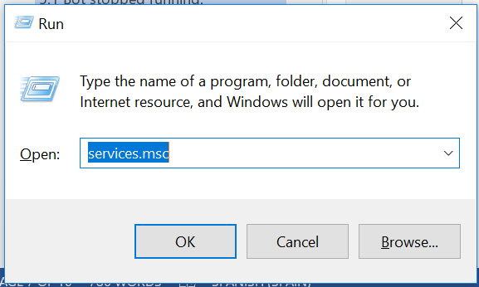
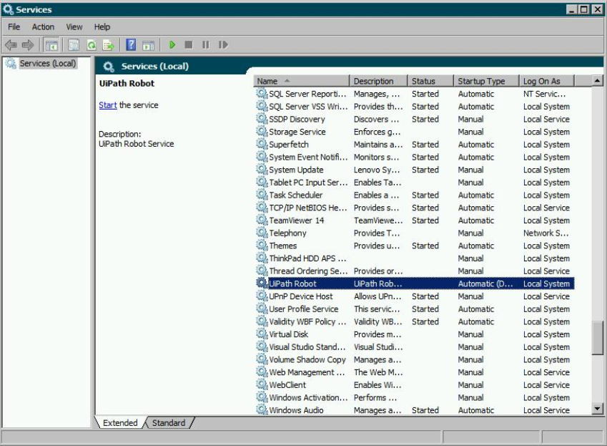
- In the Windows Services, select the UiPath Robot service. Once selected, on the left side, click Start the service.
- Wait until the UiPath Agent change the status to Connected, licensed.
- The robot/s should now become Available. For unattended robot/s, we just have to wait for the Orchestrator to run the job. The predefined schedule will trigger the next job.
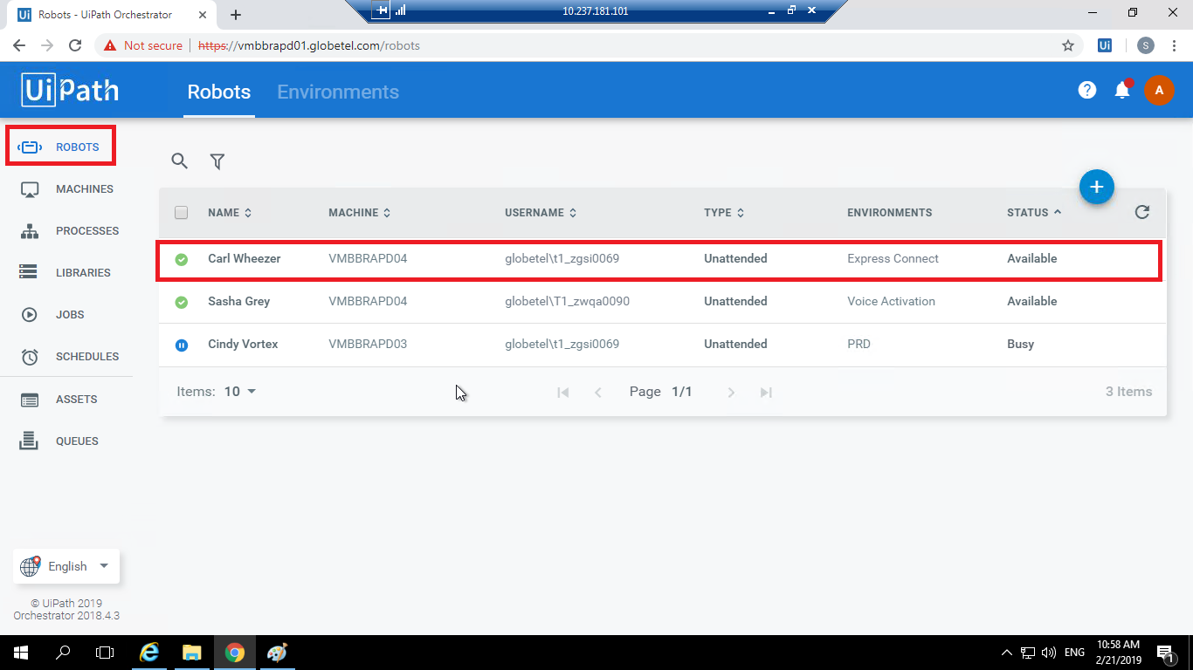
- It is recommended to monitor the next run of the bot by accessing the remote desktop through a different server, to check as to why the bot stopped running the job.
- Double check if all the Preconditions on Running the Robot/s are correctly defined.

- RUNTIME GUIDE
  - RUNTIME DIAGRAM [ARCHITECTURAL STRUCTURE OF THE MASTER PROJECT]
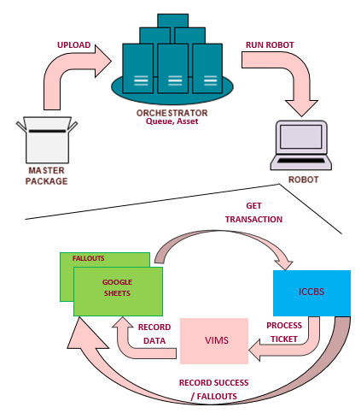

The package will be deployed to the Orchestrator. The Orchestrator will then run the robot based on the schedule that is set to 12:00 AM to 11:59 PM. All the tickets that the ROBOT will read will come from the Queue of Orchestrator which all the data are from the Business Unit. After the transaction has been taken, the ROBOT will navigate to the ICCBS web tool to process the job orders, then generate a script for deletion and activation of the facility. After successful processing, the ROBOT will then return to the Google sheet to send an email for the successfully processed job order. All the fallouts will be written on a separate tab on the Google Sheet for monitoring.
LIST OF PACKAGES (Performer)
PACKAGE | HIGH-LEVEL DESCRIPTION
1.0.7081.27298 | Enhancement on 3 performer bots: Updated EXTC facility details
1.0.7135.24433 | Enhancement on closing of multiple browsers
1.0.7151.38856 | VEH Merging + Update LuzVismin File as of 7/30

LIST OF PACKAGES (Dispatcher)
PACKAGE | HIGH-LEVEL DESCRIPTION
1.0.7201.20365 | Enhancement on preventing duplicate work order upon dispatching
1.0.7201.20376 | Added configurable asset to filter job type and prioritization of sorting of cancel status Y over N.

  - MASTER PROJECT RUNTIME DETAILS
Details of the automated process.
 | DETAILS | DESCRIPTION
1 | Production environment details | - Performer_-_Voice_Activation - Performer Robot covering Voice Activation process
2 | Prerequisites to run | - VIMS is already logged in.  - VIMS pop-up in Internet Explorer should be set to Allowed.  - Assets (Credentials, URLs) are updated in Orchestrator.
3 | Input Data | - GenerateScript_LookUp (Excel File)  - VIMSMapping  - MSAN_DATABASE_SCRIPT_OPS_OFFICIAL_Updated as of July 30 2018  - Placeholder (Text File)  - Project Neutron-065b56ac35cf (API- P12)  - project-neutron-08f0440dbd68(API- P12)
4 | Expected Output  (output data) | - ActivateScript  - DeleteScript
5 | How to start the automated process? | - Manual Run (UiPath Robot)  - Schedule Run (Schedule in Orchestrator)
6 | Resuming the process from a particular step | - Getting of Transaction Item / Data
7 | Reporting  (queues reporting, Kibana or another  platform) | - Google Spread Sheet for Success and Error Report
8 | Manual Error Handling  (Roll back or manually complete failed transactions). Procedures to reset the item. Ex “set status as investigating” | - Business Exception and System Error will consolidate in Error/ Fallout Report.
8 | a. How to resume the  process in case of error | - Exception Handling – Try Catch
8 | b. How to manually fix  transactions with error | - Exception Handling – Throw
9 | Use of Orchestrator
9 | Password policies (specific compliance requests?) | - It depends on the L1 and L2.
9 | Stored Credentials: (Never hardcode credentials in the workflow) | - All credentials are stored in Orchestrator Asset.
9 | List of Asset Names: (Follow naming convention ProcessName_AssetName) | - ICCBS_URL_Prod  - VA_GoogleSheet_Password  - VA_KeyPath  - VA_GoogleSheet_ServiceAccountEmail  - VA_GoogleSheet_Error_SpreadSheetID  - VA_Success_Job_Details  - VA_Fallout_Job_Details  - VA_AreaCode_Proj8
9 | List of Queues Names (Follow naming convention ProcessName_QueueName) | - Voice Activation
9 | Schedule details: | - 24/7 – every 2 minutes
10 | Multiple resolutions supported (in case of image automation/ Citrix) | N/A
10 | Recommended resolution | N/A

- IMPLEMENTATION
  - IMPLEMENTATION PLAN
    - SYSTEM / RESOURCE CONFIGURATION
SYSTEMS | DESCRIPTION | VERSION  (Optional) | IDENTIFIER  (Optional)
VIMS | Virtualized IP. Multimedia Services. Web tool used by globe business. | 2008-120 | 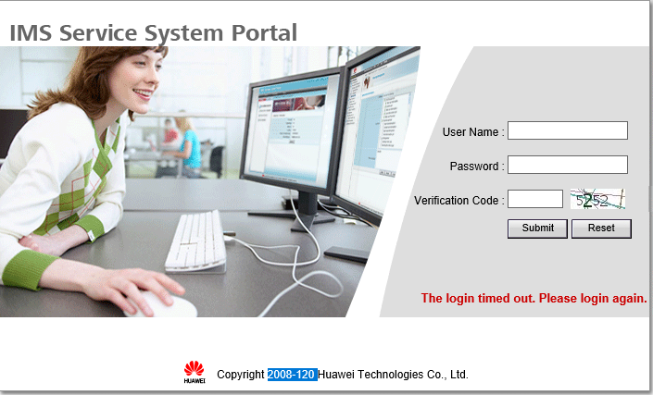
Orchestrator | UiPath Orchestrator is a server-based application that lets you orchestrate your Robots, hence the name Orchestrator. It runs on a server and connects to all the Robots within the network, whether Attended, Unattended, or Free.  Note: All Credentials, URLs must be updated. | Orchestrator 2019.4.4 | 

    - CRITERIA OF COMPLETION OF THE EXECUTION AND VERIFICATION
- Execute the process and complete successfully.
- Generating of Script for SIP and Non–SiP with Successful execution.
- Consolidation of Success and Error Report in Google Sheet.

  - IMPLEMENTATION GOVERNANCE
- N/A
  - IMPLEMENTATION SCHEDULE
NO | TASK | DEPENDENT ON TASK | START TIME | FINISH TIME | DATE | OWNER | COMMENTS
January 29, 2020
1 | UAT |  | 2:00PM | 4:00 PM | January 29, 2020 | - Moses Melgar  - Dexter Cadorna
January 31, 2020
2 | Orchestrator Migration | - Assets  - Credentials  - Package  - Schedule | 10:00PM | 10:20PM | January 31, 2020 | - COE Teams

  - CONTINGENCY AND BACKSPACE

NO | SCENARIO | ACTION REQUIRED | OWNER
1 | Check if VIMS is logged in | When bot determine if VIMS is already logged in, Bot will perform VIMS Refresh
2 | Check if login to ICCBS is successful | When the bot opens the login page for ICCBS in Internet Explorer and inputs the valid credential
3 | Generate Script for Deletion | When the given context is met  Bot will  >Generate script for Deletion  >Copy Generated Script
4 | Generate Script for Activation – SIP | When the given context is met  Bot will  >Generate script for Activation - SIP  >Copy Generated Script
5 | Generate Script for Activation - NON-SIP | When the given context is met  Bot will  >Generate script for Activation - NON-SIP  >Copy Generated Script
6 | Run Script and Get task name - Successful | When the given context is met, bot will proceed to  VIMS Switch >> Batch management Tab >> Batch Task. Click Create.  >Select "input text" under upload type tab.  >Paste generated Script (combined generated script if deleted and activated) in the text tab then click submit.  >Check if 100% successful or has error counts.  >Execution successful if has 0 error counts.
7 | Set Status to COM | When Bot Identifies the script execution has succeeded remarks, bot will proceed to set the JO status to COM.  > Click JO > under Job activity list click COM>Submit
8 | Successful Consolidated sheet | When bot successfully set the JO Status to COM
9 | Write in Consolidated error Gsheet | When any of the given criteria is met.

- CONTACTS
  - BUSINESS OPERATIONS TEAM
NAME | CONTACT NUMBERS | ROLE RESPONSIBILITY | AVAILABILITY  (FROM-TO) | ESCALATION ROUTE
Maria Stellar Gatchalian | +639176882645 | Project Owner
Ces Lagunilla | +639176884351 | Project Manager
Joed Viray | +639176882898 | BA
Jerome Villaflor | +639154579372 | SD

  - RPA DELIVERY TEAM
NAME | CONTACT NUMBERS | ROLE RESPONSIBILITY | AVAILABILITY  (FROM-TO) | ESCALATION ROUTE
Charmaine Alcantara | +639178640429 | Scrum Master
Shiela Mae Rojero | +639067196347 | Team Lead / RPA Dev
Exelyn Caborda | +639497944297 | RPA Dev
Juan Miguel Jose | +639173222497 | RPA Dev
Keean Quing | +639759179029 | RPA Dev
Jelai Bolleser | +639664524569 | RPA Dev
Miguel Magallanes | +639228635574 | QA/Tester
Ric Jayson Ubaldo | +639365235582 | QA/Tester

  - SUPPORT AND OPERATIONS TEAM
NAME | CONTACT NUMBERS | ROLE RESPONSIBILITY | AVAILABILITY  (FROM-TO) | ESCALATION ROUTE
Mae Makiling | +639985499925 | RPA Support/ L3
IT Shared | +639178516793 | L1 / L2

